**Step 1 - Create the User Interface (UI) with Tkinter**

1. Download the starting files from the course resources.

2. Use the images in the image folder, to create the following user interface. The ❌ and ✅ are buttons. You can add images to buttons like this:

1. my\_image = PhotoImage(file="path/to/image\_file.png")
2. button = Button(image=my\_image, highlightthickness=0)

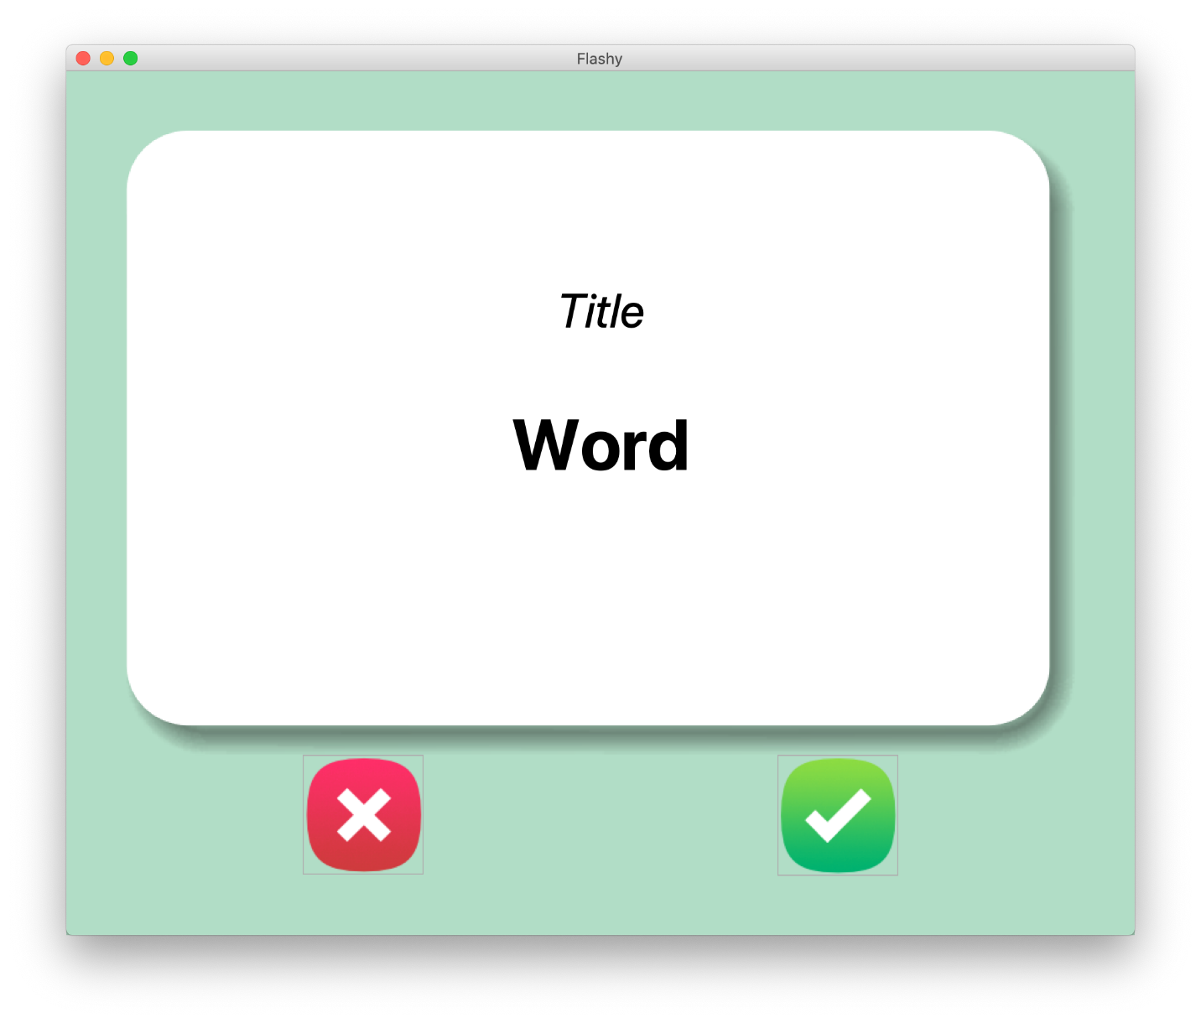

3. Here are some hints for the fonts, measurements and positioning.

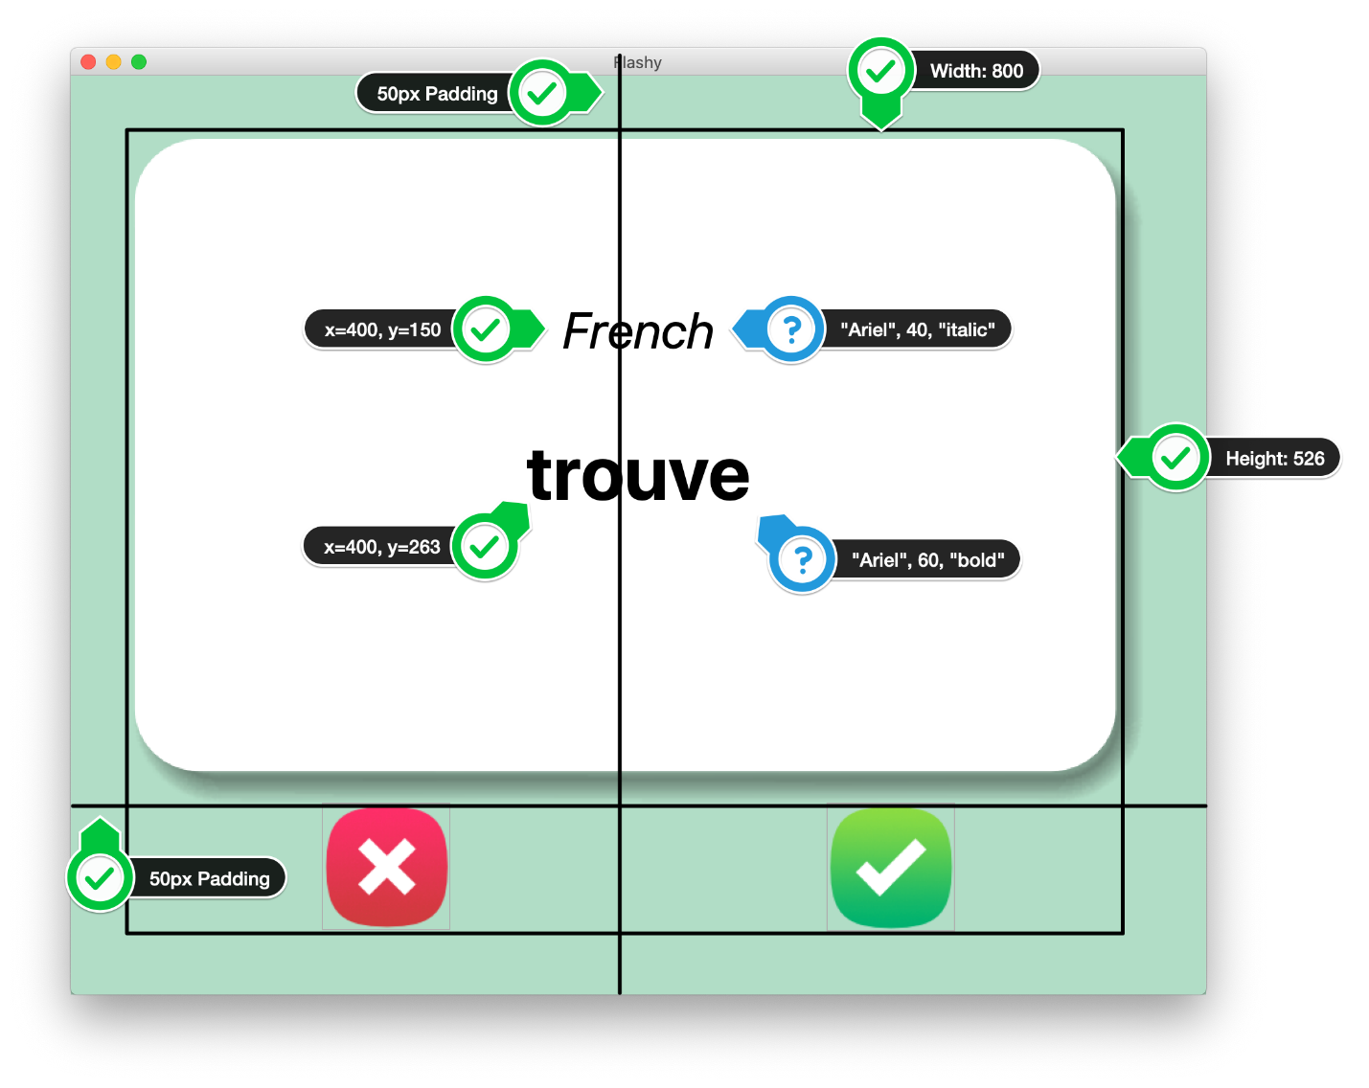

HINTS:

1. You will need a 2 X 2 grid, with the flash card taking up 2 columns.

2. The flash card is a [Canvas](https://effbot.org/tkinterbook/canvas.htm) with 1 image and 2 pieces of text.

3. The image is card\_front.png, created from the [PhotoImage](https://effbot.org/tkinterbook/photoimage.htm" \t "_blank) class. Be careful about the full image path as the image is inside the image folder.